Palmar arterial arches

Superficial palmar arch

Location
Located between palmar aponeurosis and long flexors tendons

Formation
- Ulnar side: superficial branch of ulnar artery
- Radial side: variable – branches of radial artery
  - Most common - Superficial palmar branch of radial artery
  - Sometimes - Other branches of radial artery - Princeps pollicis or radialis indicis
  - Rarely – median artery – branch of anterior interosseous artery completes the arch

Branches
- Three common palmar digital arteries – joins the palmar metacarpal arteries
  - Each common palmar digital artery divides into two proper digital arteries
- Palmar digital artery – to ulnar side of little finger – arise directly from the superficial palmar arch

Relations
- Superficially – palmar aponeurosis
- Deep – long flexor tendons with lumbricals

Surface anatomy
Convex line drawn at distal border of fully extended thumb across the palm to meet hook of the hamate represents the superficial arch
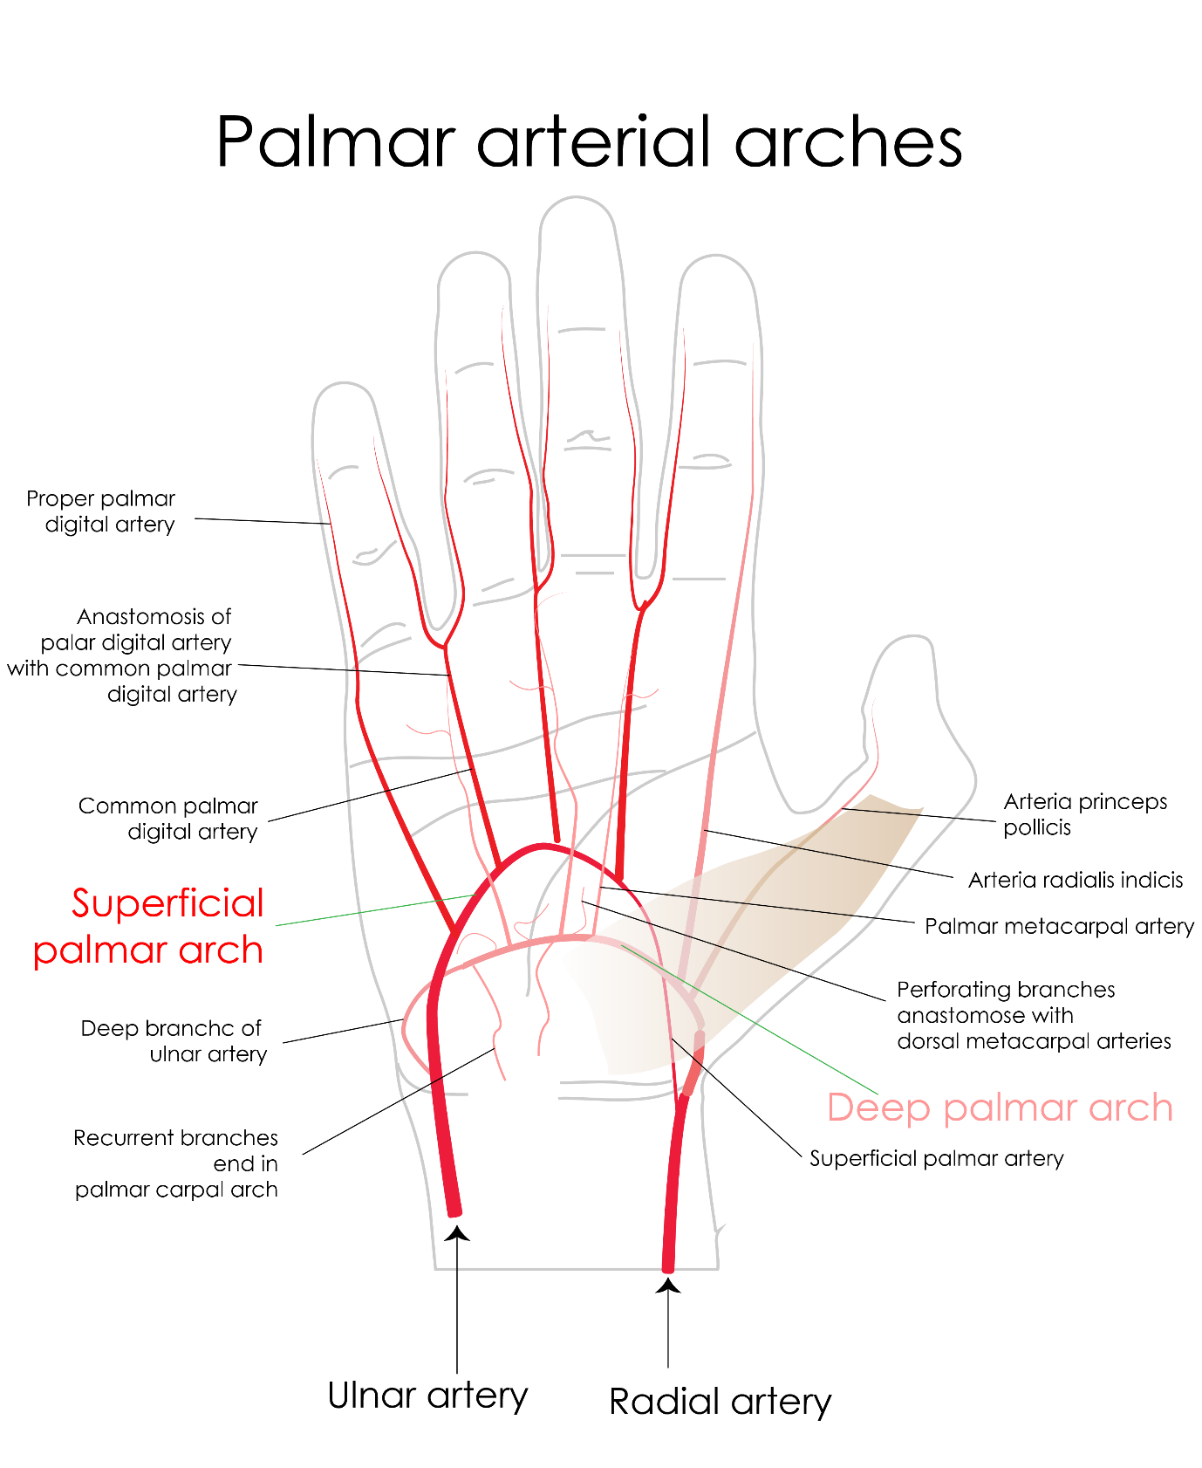
[YOUTUBE] https://youtu.be/58mb7tFPmDI

Deep palmar arch

Location
Located deep in the palm between flexor tendons and intersossei muscles

Formation
- Radial side: Continuation of radial artery
- Ulnar side: deep branch of ulnar artery

Branches
- Three palmar metacarpal arteries – joins the common palmar digital arteries
- Three perforating arteries – passes dorsally and anastomose with dorsal metacarpal arteries
- Recurrent arteries – runs proximally and joins palmar carpal arch

Relations
- Superficially – long flexors and lumbricals
- Deep – interossei muscles and metacarpals
[TIP] Deep branch of ulnar nerve lies in the concavity of deep palmar arch

Surface anatomy
- Horizontal line drawn across the palm from the distal point of hook of hamate
- It is 1 to 1.5 cm proximal to superficial palmar arch

Applied anatomy
Allen’s test: Allen test measures arterial competency, and should be performed before taking an arterial sample.

Release the occlusive pressure on the ulnar artery only to determine whether the modified Allen test is positive or negative.

Positive modified Allen test – If the hand flushes within 5-15 seconds it indicates that the ulnar artery has good blood flow; this normal flushing of the hand is considered to be a positive test.

Negative modified Allen test – If the hand does not flush within 5-15 seconds, it indicates that ulnar circulation is inadequate or nonexistent; in this situation, the radial artery supplying arterial blood to that hand should not be punctured
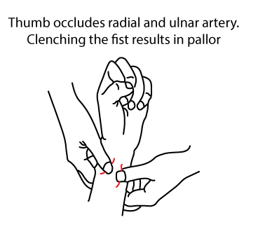
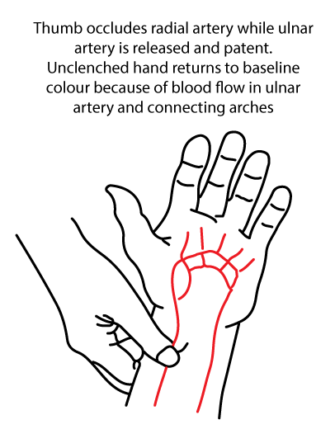
[CLINICAL]Radial artery is the most popular arterial graft after the left internal thoracic artery
The Allen test is the most widely used clinical test for preoperative evaluation of sufficient ulnar collateral circulation to the hand

___MCQ_START___
Q1. The superficial palmar arterial arch is formed predominantly by which artery?
A. Radial artery
B. Ulnar artery[CORRECT]
C. Anterior interosseous artery
D. Deep palmar branch of ulnar artery
___
Q2. The superficial palmar arch lies in which anatomical plane of the palm?
A. Deep to interossei muscles
B. Deep to flexor tendons
C. Superficial to flexor tendons[CORRECT]
D. Between metacarpal bones
___
Q3. Which artery mainly completes the deep palmar arterial arch?
A. Superficial palmar branch of ulnar artery
B. Radial artery[CORRECT]
C. Common digital arteries
D. Princeps pollicis artery
___
Q4. The deep palmar arterial arch is located at which level in the palm?
A. At the level of distal palmar crease
B. At the level of metacarpophalangeal joints
C. At the base of metacarpal bones[CORRECT]
D. At the level of proximal phalanges
___
Q5. Which arteries arise from the superficial palmar arterial arch?
A. Palmar metacarpal arteries
B. Dorsal metacarpal arteries
C. Common palmar digital arteries[CORRECT]
D. Proper digital arteries of thumb
___
Q6. The deep palmar arterial arch gives rise to which branches?
A. Common digital arteries
B. Palmar metacarpal arteries[CORRECT]
C. Proper palmar digital arteries
D. Dorsal digital arteries
___
Q7. Injury to the radial artery at the wrist is least likely to compromise hand perfusion due to contribution from:
A. Posterior interosseous artery
B. Anterior interosseous artery
C. Ulnar artery via palmar arches[CORRECT]
D. Deep circumflex iliac artery
___
___MCQ_END___

